Lecture 1
Version control or source control is the practice of tracking and managing changes to software code. Two types:
1. Centralized (CVS, Subversion, Perforce)
2. Decentralized or distributed (Git, Mercurial, Bazaar, Darcs)

git clone [URL]-> retrieve an entire repo hosted in the URL
git pull-> fetch and merge any commits from the tracking remote branch
git push [alias] [branch] -> Transmit local branch commits to the remote repository branch
git branch-> list all the branches (* indicates the current branch)
git branch [branch-name]-> create a new branch at the current commit
git checkout-> switch to another branch and check it out into working directory
git fetch [alias] -> fetch down all the branches from that Git remote

characteristics of java
• Simple
• Object-oriented
• Distributed
• Robust
• Secure
• Architecture-neutral
• Portable
• High-performing
• Multithreaded
• Dynamic

1️⃣ JRE (Java Runtime Environment)
Purpose: Run Java programs.
It includes:
- JVM (Java Virtual Machine) → executes the Java bytecode
- Core Java libraries → standard classes needed by programs
- Other supporting files
👉 So JRE = everything needed to run Java applications.
You cannot develop or compile Java programs with just JRE.

2️⃣ JDK (Java Development Kit)
Purpose: Develop (write + compile) Java programs.
It includes:
- Development tools (like javac compiler, debugger, etc.)
- JRE (so programs can also run)
👉 So JDK = tools for developers + JRE

Bytecode is .class file, and the file itself is binary, but not CPU binary. It is designed for JVM not the CPU. So something gotta convert it to machine code. And that is:
Native code = machine code that your specific CPU understands directly.
JIT(Just in time compiler) = a compiler inside the JVM that converts bytecode into native machine code while the program is running. JVM runs the bytecode.
Garbage Collector (GC) - It automatically deletes unused objects from memory. We do not have a guarantee when exactly will GC free the memory.
JVM → engine that runs Java
├── JIT (makes code faster)
└── GC (cleans memory)

Class name shall correspond to the file name. If class is “HelloWorld”, then the file shall be named as “HelloWorld.java”

Passing parameters to the application
class ParamApp {
public static void main(String args[]) {
System.out.println(“The first parameter is: ” + args[0]);
System.out.println(“The second parameter is: ” + args[1]);
}
}
Compilation:
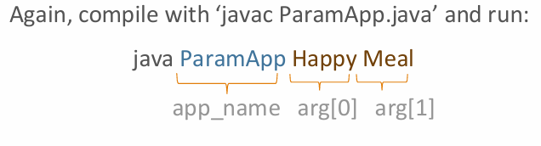

Stuff from Java:
boolean – keyword of bool type (additional from C, also byte type.). it cannot take 0 or 1 as value. It contains true or false (with lowercase)
boolean bStudent = 0; // Error
if (bStudent == 1) { // Error}

Also a non-zero integer won’t express true in if statements:
int flag = 1;
if(flag) {/*some statement*/} // Error

Non-primitive types - reference types
No unsigned integers

Java char – is 2 bytes from Unicode, from 0 to 65535. char letter = ‘Ə’;

Escape sequences - Below are single characters, even though it looks like 2 chars.
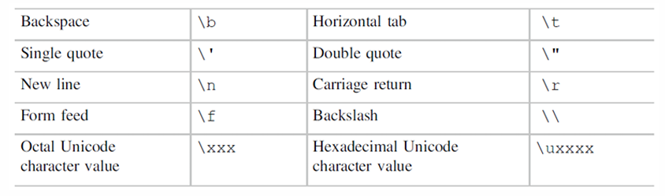

Literals
By default, integer literals are of type int.
To specify a value as long, “l” or “L” shall be added: 12l or 175L.
By default, floating-point literals are of type double.
To specify a float literal, “f” or “F” shall be added: 13.5f or 772.34F.

To group numbers use underscore _, it is discarded during the compilations
int a = 12_345;
double b = 5_134_345.56;

Java is Statically typed programming language – which means all variable types shall be provided during the declaration, like in C, not like in Python. In java You can’t change the type of the variable, which is strong typing. Python is weak typing.

var keyword - We do not need to explicity declare the variable type, compiler will figure out the exact type.

Between opening curly braces and closing - a block
Scope and lifetime of variables – local variables cannot have same name, but global variables(aka class variables) can be overwritten.
class AppName {
int a = 5; // field
public static void main(String args[]) {
int a = 7; // it is ok – a is declared in class scope
int b = 99;
if (b < 100) {
int b = 20; // error - b is already declared
}
}
}

Local variables shall be initialized before use. Java doesn’t allow printing garbage values, it raises error. But global variable can be uninitialized as it will be 0.
class test {
int a = 5; // field
public static void main(String args[]) {
int a; // local variable
System.out.println("a=" + a);
//a should be initialized before used ERROR
}
}

The default values of global(class) variables:
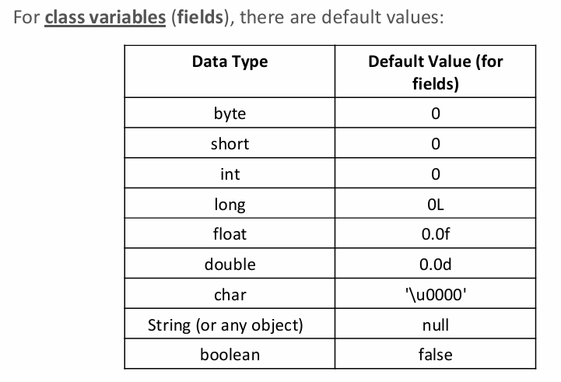
Arithmetic operators
int a = 8 / 3;
int r = 8 % 3;
double b = 8 / 3;
double c = 8.0 / 3.0;
double d = 8.0 % 3.0;
System.out.println("a: " + a); //2
System.out.println("r: " + r); //2
System.out.println("b: " + b); //2.0
System.out.println("c: " + c); //2.6666666666666665
System.out.println("d: " + d); //2.0

Logical operators
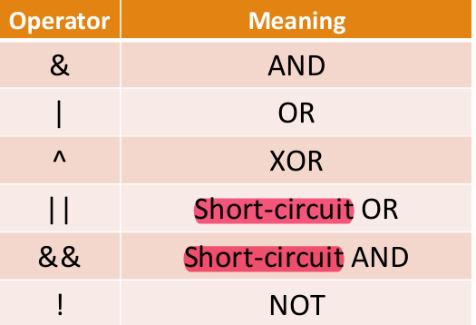
Bitwise operators
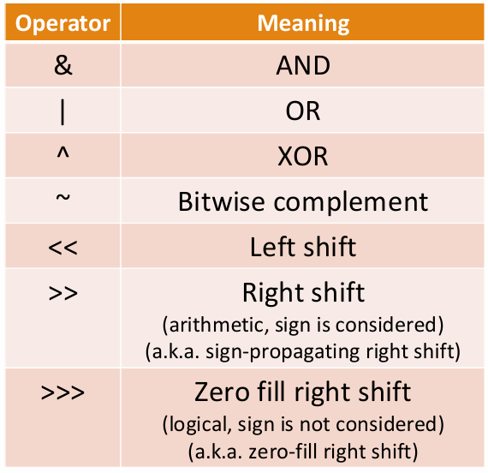
Example for shifts
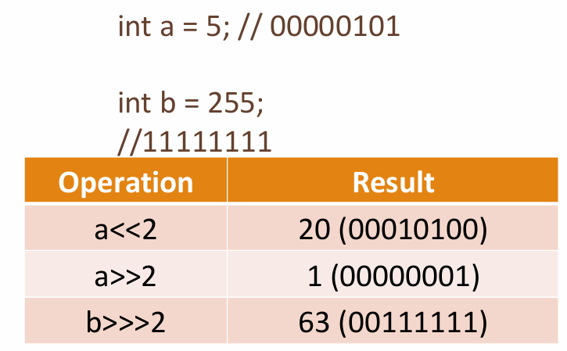

Associativity
When an expression has two operators with the same precedence(oncelik), the expression is evaluated according to its associativity.
For example, x = y = z = 5 is treated as x = (y = (z = 5)). Bc = operator has right-to-left associativity.
75 / 3 / 5 is treated as (75 / 3) / 5 since the / operator has left-to-right associativity

Two’s complement
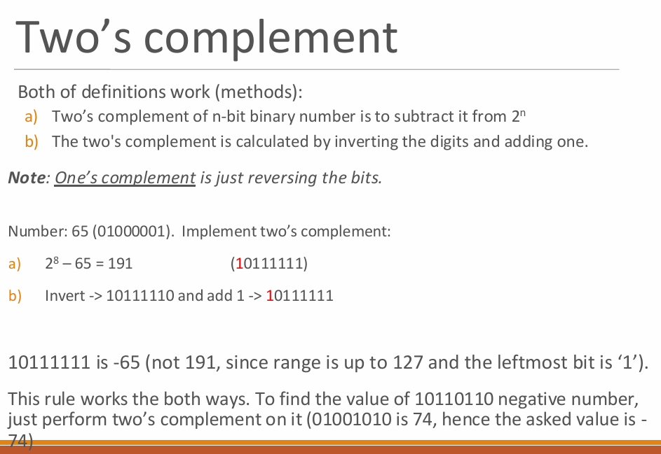
Two’s complement rule is not applicable to the most negative number. In 8 bit system, -128 is 10000000
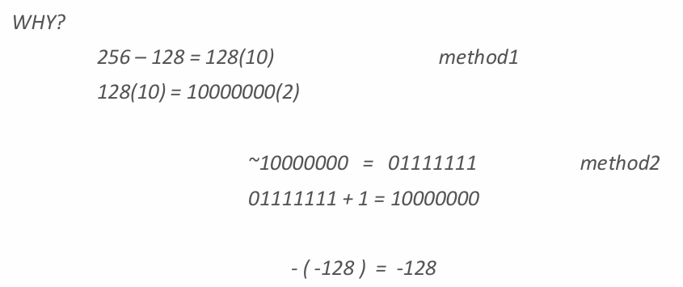
The key difference is that the most negative number has no positive counterpart in two’s complement. Because 128 positive number doesn’t exist in 8 bit system.

Short circuiting
// if (a<=0) then the second part will not be evaluated
if ( (a > 0) && (b < 10))
// if (a>0) then the second part will not be evaluated
if ( (a > 0) || (b < 10))

Note: It is not common to use the non-short-circuiting versions (&and |) with boolean expressions. See the difference below:
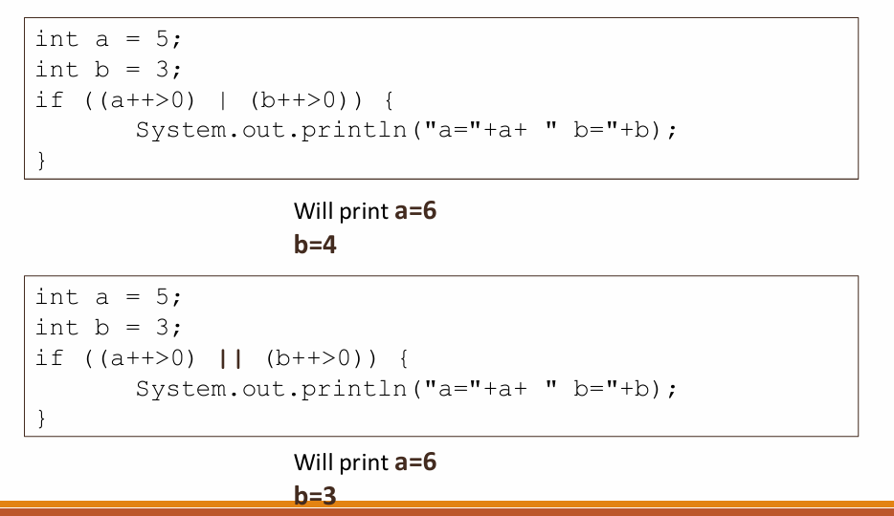

Packages
Java packages are basically folders.
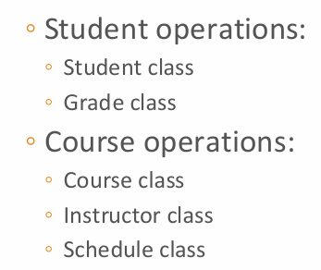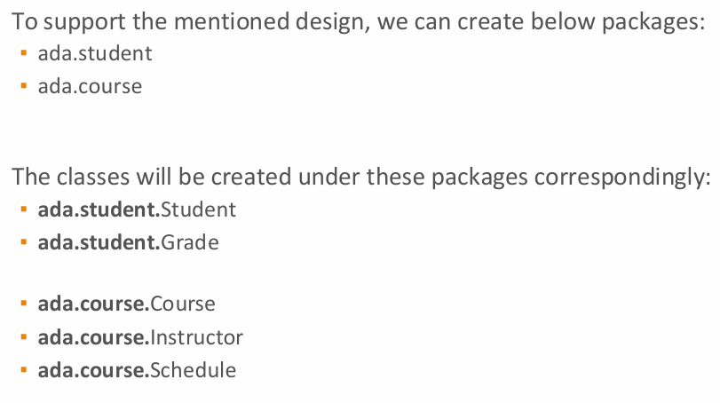
When you compile a class with the package, add “-d .”parameter to create package folders: javac –d . Student.java or to compile all files of the project: javac -d . *.java
With -d
javac -d . Student.java
Now Java reads:
package ada.student;
and creates folders automatically:
./ada/student/Student.class
So:
-d = destination folder
Naming:
Package names should contain only the lowercase letters. Companies usually use their internet domain names (in the reversed way) (e.g., az.edu.ada.site.pp2)
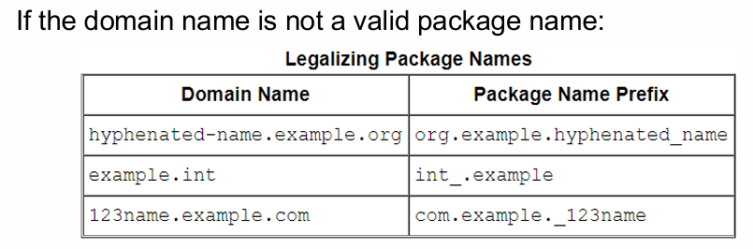
Problem | Why invalid | Fix
hyphenated-name | - not allowed | hyphenated_name
int | Java keyword | int_
123name | cannot start with digit | _123name

Java’s packages start with java. or javax.
Importing packages
To use all classes of the particular package, we need to import it:
import ada.student.*;
To use the specific class of the package, we can only import the class
itself:
import ada.student.Grades;

Java Math library
java.lang package is imported by java automatically. Still for showcase:
import java.lang.Math;
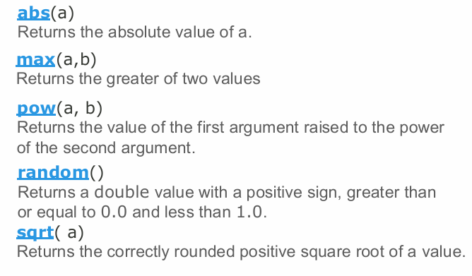

Type conversion
Automatic = implicit = coercion
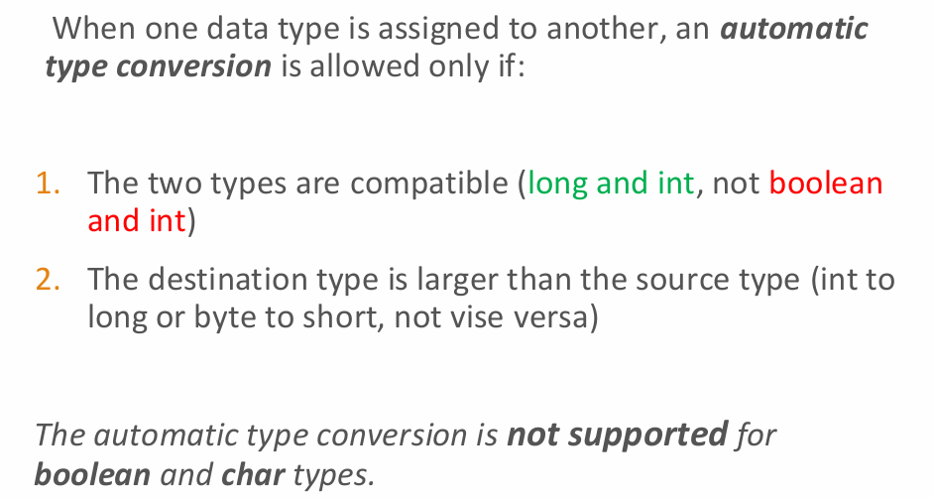
Casting = explicit - for forcing the conversion that doesn’t happen automatically
double d = 2.4;
int x = (int) d;
int y = (int) 10.2/3;
When double or float is casted to integer values, the fractional part is lost.
Answers are not predictable when from long to short memory cast happens:
long longVal = 111222333444l;
short shortVal = (short) longVal; // left bits are lost
long longVal2 = -3434646l;
short shortVal2 = (short) longVal2; // left bits are lost //see the sign bit
System.out.println("longVal: " + longVal); // 111222333444
System.out.println("shortVal: " + shortVal); // 8196
System.out.println("longVal2: " + longVal2); // -3434646
System.out.println("shortVal2: " + shortVal2); // -26774

Input reading
1. import java.util.Scanner
2. Create Scanner object:
Scanner sc = new Scanner(System.in);
3. Use a relevant method to scan any datatype:
Integers:
int i = sc.nextInt();
Floats:
float f = sc.nextFloat();
char:
char symbol = (char) System.in.read();

Switch – supported data types are byte, short, int, char, enum, string.

For loop
